Contents
++++++++++++++++++++++++++++ 1
*** Visa summaries 1
++++++++++++++++++++++++++++ 1
Vietnam 1
Cambodia 1
Laos 2
Thailand 2
*** Itinerary, with visa notes 3
***Credit card and financial phone info 3
++++++++++++++++++++++++++++ 3
*** SE Asia 3
++++++++++++++++++++++++++++ 3
Flights 3
Phone numbers 4
Upon arrival in Saigon 4
Minh Chau Hotel 5
Tips Tricks and Traps 5
Trains 6
Regional air travel 6
Health 6
++++++++++++++++++++++++++++ 6
*** Other countries and contacts 6
++++++++++++++++++++++++++++ 6
Sky Ratnam homestay (Ann) 6
Reggae GH 2, Kuala Lumpur 6
++++++++++++++++++++++++++++ 7
*** Thailand 7
++++++++++++++++++++++++++++ 7
On arrival at Bangkok airport 7
Map 8
Health 9
Tips Tricks and Traps 9
Cities and Towns 9
Flights to India 10
Visa 10
Online Guides 10
Massage 10
Food 10
Currency 10
Weather 11
Rail 12
Trains to/from BKK and Hualumphong 12
State Railway of Thailand 12
Bus 13
Accommodation 13
Bangkok 13
Chiang Mai 13
Health 13
Tips Tricks and Traps 13
Cities and Towns 13
++++++++++++++++++++++++++++ 13
*** Malaysia 13
++++++++++++++++++++++++++++ 13
++++++++++++++++++++++++++++ 13
*** Cambodia 13
++++++++++++++++++++++++++++ 13
Telephone numbers 13
Map 14
Visa 14
Online Guides 14
Food 14
Currency 15
Weather 15
Phnom Penh 15
Rail 15
Bus 15
Accommodation 16
Kampot 16
Siem Reap 16
Health 16
Tips Tricks and Traps 16
Cities and Towns 16
Kampot/kep 16
Battambang 16
Siem Reap 17
Ratanakiri 17
++++++++++++++++++++++++++++ 18
*** Laos 18
++++++++++++++++++++++++++++ 18
Map 18
Visa 19
Online Guides 19
Food 19
Currency 19
Weather 19
Vientianne 19
Luang Prabang 19
Rail 20
Bus 20
Accommodation 20
++++++++++++++++++++++++++++ 20
*** Vietnam 20
++++++++++++++++++++++++++++ 20
Telephone Numbers 20
Van 21
Possible itinerary 21
Checklist 21
Map 23
Vietnam/HongKong 25
Cambodia 26
Laos 27
Phone 27
Health 28
Weather 28
Average Conditions 28
Hanoi 28
Ho Chi Minh City 29
Danang 30
Average high temperatures 32
Hanoi 32
Ho Chi Minh 32
Visa 33
Border Crossings 34
Online Guides 34
Food 34
Currency 34
Misc Transport 34
Buses 35
Open Bus 35
Cities and places 35
Hanoi 35
Danang 35
Ninh Binh 36
Halong Bay 36
Near Nha Trang 36
Saigon/HCMC 36
Dalat 36
Easy Riders 37
Sa Pa 37
Can Cau and Bac Ha 37
Hoi An 37
HCMC 37
Accommodation 38
Ninh Binh 38
Health 38
Tips, Tricks, and Traps 38
Cat Ba Island 38
Mekong Delta 38
Mekong River 39
Touring 39
Jazz in Hanoi 39
++++++++++++++++++++++++++++ 39
*** Indonesia 39
++++++++++++++++++++++++++++ 39
Telephone Numbers 39
Possible itinerary 39
Checklist 40
Map 40
Phone 40
Health 40
Weather 40
Average Conditions 40
Visa 40
Border Crossings 40
Online Guides 40
Food 40
Currency 40
Misc Transport 40
Buses 40
Cities and places 40
Health 40
Tips, Tricks, and Traps 40
++++++++++++++++++++++++++++ 40
*** Health Stuff 40
++++++++++++++++++++++++++++ 40
Immunizations, from other travelers 40
Immunization History 41
GHC Coverage Notes 41
Immunizations I want to get 41
Thurston County Health Dept 41
GHC Travel Meds for India and SE Asia 41
GHC Travel Advisor, India and SE Asia 43
++++++++++++++++++++++++++++ 46
*** Skeleton Categories 46
++++++++++++++++++++++++++++ 46
Telephone Numbers 46
Possible itinerary 46
Checklist 46
Map 46
Phone 46
Health 47
Weather 47
Average Conditions 47
Visa 47
Border Crossings 47
Online Guides 47
Food 47
Currency 47
Misc Transport 47
Buses 47
Cities and places 47
Health 47
Tips, Tricks, and Traps 47

++++++++++++++++++++++++++++

*** Visa summaries

++++++++++++++++++++++++++++

Note: SEAsia-directory.pdf has good summary of border crossings, with map

Vietnam
- If flying into and out of HCMC or Hanoi, 3 month sgl entry visa thru MyVietnamVisa; then 1 month sgl entry at end of trip
- If flying into HCMC and flying home from another country (e.g. BKK), then 3 mo multiple entry, thru Vietnam consular

Overland from Cambodia: You can get your visa for Vietnam in PP for around $40usd; or in BKK; or if you'll be in SihanoukVille it's $35usd at the Vietnam Consulate, takes less than half an hour.
should take approx 2days at phnom penh.

From vseznayka, TT: I am just from Battambang, Cambodia - the place where one supposed to get Vietnamese visa on a spot. to some extent it's true - the visa is iindeed nstant and costs only $25. What tourbooks don't tell you though that consulate in Battambang issues only 15-day visas max. Don't go there for visa if you need longer stay. But do go to Battambang because the boat ride from Siem Reap is an unforgettable experience.
And as for visas, I am in Phnom Phen now, and I just saw that Capitol Guest House offers assistance with 30-day and many other types of Vietnam visas. For 30-day visa they charge $40 and promise to do it in one day.

From steve252, TT: re #39:- Vietnamese tourist visa types:
- "C" class visa - good for 30 day entry permit, which can be extended
- "D" class visa - only good for 15 day entry permit, which CANNOT be extended
the Battambang consulate insists that they can/do issue "C" class visas - the price is USD30 (while you wait - same applies for the consulate in Sihanoukville)
the same visa can be obtained (albeit not as quickly) for ~USD25 via the various "lakeside" backpacker agencies/guesthouses in Phnom Penh

Another LOA for Vietnam visa:
http://www.hotels-in-vietnam.com/hotels/Travel_Vietnam/vietnam-visa.html

Cambodia
Single entry, valid for 3 mo, 30 days length of stay $25usd

Overland from Thailand, 2 crossings have VOA

Overland from Vietnam, no VOA?
http://www.tourismcambodia.com/tripplanner/entryinfo/?PID=getin seems to indicate that there are 9 border crossings with Vietnam, at 2 of which (Moc Bai and Chau Doc) there is no VOA. But posts on TT indicate that there is indeed VOA at those points.
From steve252, TT: Visa-on-Arrival for Cambodia @ Chau Doc - yes, VoA was introduced at both crossings (Vinh Xuong & Tinh Bien) in late'02 (ditto @ Moc Bai)

Overland from Laos, VOA at Dong Kralor $20

Laos
Overland from Cambodia, no VOA
Good article on visa and transport, between Laos and Cambodia
http://www.articlesbase.com/travel-tips-articles/new-frontiers-crossing-the-laos-cambodian-border-veun-kham-dong-kralor-476698.html

A Tourist Visa for the Lao PDR is available from a Lao Embassy; a Lao Visa on arrival for 30 days can also be obtained at most border crossings and ports of entry, except overland from Cambodia.

From Captain_Bob, TT: No visa on arrival at / Na Maew or Na Phao / Cha Lo
Yes visa on arrival at Nam Can / Nam Khan, Cau Treo / Nam Phao, and Lao Bao / Dansavanh / Nam Xoi

Thailand
No visa required for stay up to 30 days (if coming in by air; if by land only 15 days, according to the following)

[from TT, Thailand FAQ, 12/5/08]
So what's the deal?
While the official English translation of the order has yet to be published (and is unlikely to appear before next week due to today's holiday for the King's birthday), a combination of an unofficial translation and reports from various borders suggest the speculation is accurate. The headline change is that anyone crossing into Thailand by land, who doesn't already have a visa from a Thai embassy or consulate, will be ALLOWED TO STAY ONLY 15 DAYS, not the previous 30.
This does not apply to people flying into Thailand, who can still get 'stamped in' - or in official parlance enter under the 'tourist visa exemption scheme' - for 30 days (or 90 days if you're from Argentina, Brazil, Chile, Peru or S Korea). Or to anyone who already holds a current Thai visa.
Just in case you still don't get it: if you fly in, you get 30 days without a visa, if you come overland, you get 15.
Regional consulates
If you're on the road and decide you need a tourist visa before coming/returning to Thailand, the following cities have Thai embassies or consulates.
Laos: Vientiane and Savannakhet
Cambodia: Phnom Penh
Vietnam: Hanoi and HCMC
Myanmar: Yangon
Malaysia: KL, Penang, Kota Bharu
India: New Delhi, Kolkata, Chennai, Mumbai
Singapore
China: HK, Beijing, Shanghai, Kunming, Guangzhao, Chengdu

*** Itinerary, with visa notes

***Credit card and financial phone info
Tw* 9262 4637
MP 6098 8606
UBnk 5551 6916

For Mileage Plus Visa
Chase customer service 800 537 7783
Chase from outside US, collect 847 888 6600
Chase direct hotline for fraud 800 955 9060 (preferred line to call, I think
For Continental Master Card
Customer service 800 323 6252
Chase (Cont card) from outside US, collect 512 623 7702
Direct hotline for fraud 800 955 9060 (same as for Visa)
American Express
American Express customer service 800 257 0770
American Express from outside US, collect 336 393 1111
Lost passport, lost luggage, medical or legal help or referral, emergency translation, weather update, emergency cash wires, or possibly other problems
Twinstar
Twinstar 360 357 9911
Twinstar outside US secure message from home page
10/1/11: sent msg thru online system
US Bank
USBank 800 872 2657
USBank outside US, collect 503 401 9991

The Hartford 800 423 6789 policy #55 PHE513490

++++++++++++++++++++++++++++

*** SE Asia

++++++++++++++++++++++++++++

Good site with lots of info
http://sites.google.com/site/chaskemp/asia_travel

Recommended hotel site, by Hunter guidebook
http://asia-hotels.com/

Flights
Continental Confirmation Number: D1LCKG
United Confirmation Number: P25P52
All Nippon confirmation number: AVIBYP 800 235 9262

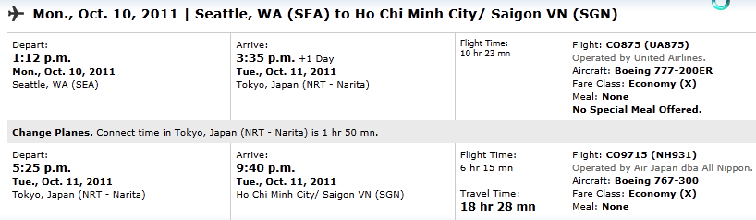
All Nippon/Air Japan
seat: 37B
Checked bags: 2 @ 50lbs free (23kg)

From Continental customer service:
“Visitors are required to have proof of sufficient funds to cover their stay and documents required for their next destination”

Phone numbers
All Nippon 800 235 9262
Continental Reward Asia 800 344 1411

Upon arrival in Saigon

From MyVietnamVisa: present at airport:
- Original passport
- 02 photos 4x6CM
- Letter of visa upon arrival
- Stamping fee $50
- On arrival form (you can download it here and fill out in advance)
If you have any questions or would like to speak to a customer service representative, please call our Hanoi office at +84-909-333-023 or email us at sales@myvietnamvisa.com.

From nervouslady, tt: I obtained a LOA from MyVietnamVisa and there were no problems at all with the legitimacy, cost, convenience or speed of service (letter was emailed to me within three days as promised). However- a couple of things you should take into account.
1. When you get the letter it will have your name and the name of several other tourists, together with their dates of birth, nationality and passport numbers. So if you are concerned about privacy this may not be the option for you.
2. When you arrive in HCMC you will have to go to another counter (not very well sign-posted) to get your visa before proceeding to the immigration queues. I waited half an hour at this counter even though there were only 10-15 other people ahead of me and 4 people working in the office. In the meantime all the other passengers on my flight cleared immigration, collected their bags and my baggage was going around on the carousel unattended when I finally got there.
3. I saw a few people in the queue who had not filled out the exit and entry form and attached the passport photos and they were being given a very hard time (mind you, there really is no excuse for not knowing this part-your LOA provider will explain the process quite clearly)

Minh Chau Hotel

http://minhchauhotel.com/location-c74.html

Address: 119 Hòa Hưng,W.12, D.10.
Telephone: (08) 38626705 - (08) 386 26 706
Fax: (08) 397 97 600
Number Manager : Phu Nguyen, 0903 632 260 - 0942 865 910

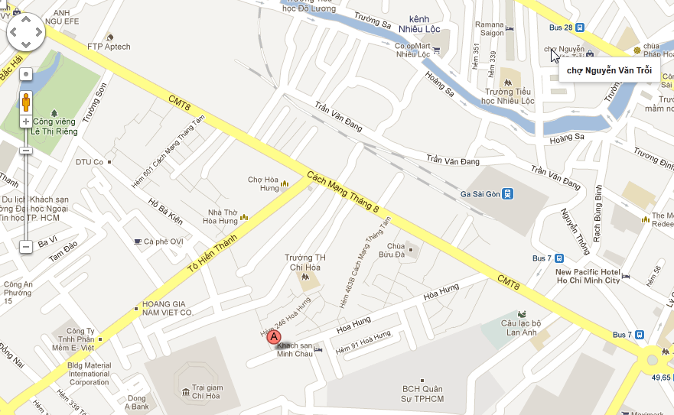

Tips Tricks and Traps
- Saigon taxi's - watch out for jumping meters, I ended up jumping out of the taxi half way through the journey! Poipet Thai-Cambodia border crossing - Once of the bus stops off you will be surrounded by tuk tuk drivers waiting to take you to the "border" which is really just a small building with a make shift sign and no security guards. Men in suave shirts will ask you to pay your crossing fee in baht instead of dollars....try and keep cool about the situation and get your tuk tuk to drop you off at the nearest guesthouse (you may be followed so they can pick u up the next day) either get a metered taxi to the border or ask around around town for the best way to cross!
- Look at http://www.talesofasia.com you'll find great information on traveling overland to Cambodia. Including step by step directions for DIY travel, and how to avoid the scams along the way.
- Make sure to use up or change Dong/Kip before you leave. They are useless outside their home country

Trains
http://www.seat61.com/Vietnam.htm

Regional air travel
www.skyscanner.net
www.attitudetravel.com
www.lonelyplanet.com

Health
http://sites.google.com/site/chaskemp/asia_travel has good section on hospitals & clinics in SE Asia

Sunscreen ratings
http://www.ewg.org/2010sunscreen/finding-the-best-sunscreens/?search=&brand_id=1128&ptype=sunscreen

++++++++++++++++++++++++++++

*** Other countries and contacts

++++++++++++++++++++++++++++

Sky Ratnam homestay (Ann)
1/542, Pattalam Market Road (or 1/1542)
Near Sangeetha Travels
Kochi
Kerala - 682001
India
(stayed there 10 to 13 Jan 2011)
Ph 0484 2218684

Reggae GH 2, Kuala Lumpur
206 1st floor
Jaian Tun H.S.Lee
50000 Kuala Lumpur
Tel 03 2078 9163
Stayed there 10/29

++++++++++++++++++++++++++++

*** Thailand

++++++++++++++++++++++++++++

On arrival at Bangkok airport
- you might want to withdraw 9800 baht to get some small change. Plenty of atm's at arrivals, and even some atm's airside.
- Numerous ATM machines inside the airport. Even have little bank booths with people in if you prefer to use those.
- At Swampy, on the arrivals level (2), the ATMs can be found next to most of the currency exchange booths.
- as you walk out of customs intothe arrivals hall yu will be confronted by a bank and ATM
- right after immigration, before customs there's an ATM, also just before you exit the airport there's a couple.

Map
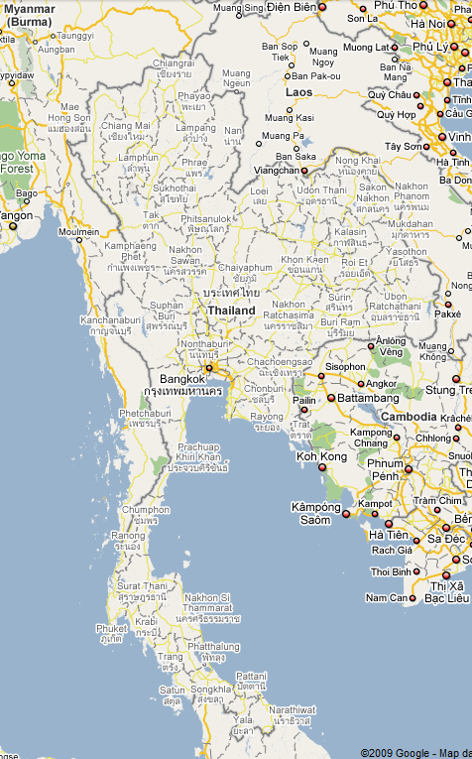

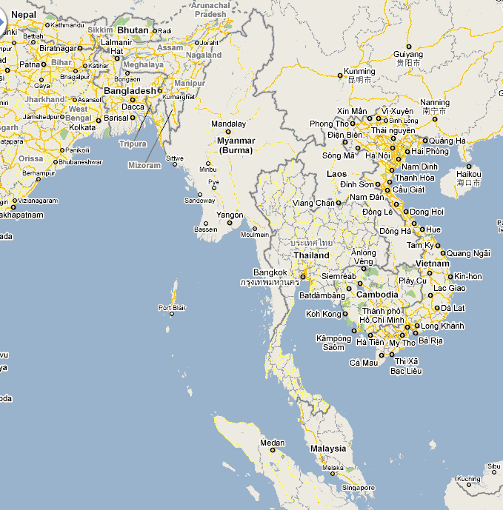

Health

Tips Tricks and Traps

Cities and Towns
Bangkok: King’s bd celebration Dec. 5. Huge, with parades, and hordes of people

Flights to India
India FAQ #64: From Bangkok - One of best travel agencies to check is IBS TRAVEL off a small lane on left hand side of Khao San Rd in direction of Tanao rd . Check their promotion fares listed on back wall .
Also: BIMAN BANGLADESH AIRWAYS
DRUK BHUTAN AIRWAYS

Visa
• No visa required for stay up to 30 days
• Tickets and Documents for return or onward travel

Online Guides

Massage
Here are some good Thai words to know if you like Thai massage:
Nuat = massage (noo aht)
Shop = like
Bao bao = softly (bow like as in the bow of a boat)
Knock knock = hard pressure
Maak = a lot (sounds like Mark)
Jep = hurt
Dee = good
Sabai Dee = I am fine
You will always hear Sabai Dee mai? Are you OK? Answer: Sabai Dee!
Example: shop nuat bao bao = I like soft or gentle massage (lit: like massage softly)

Food

Currency
1000 Thai baht = 30.87400 U.S. dollars

Weather
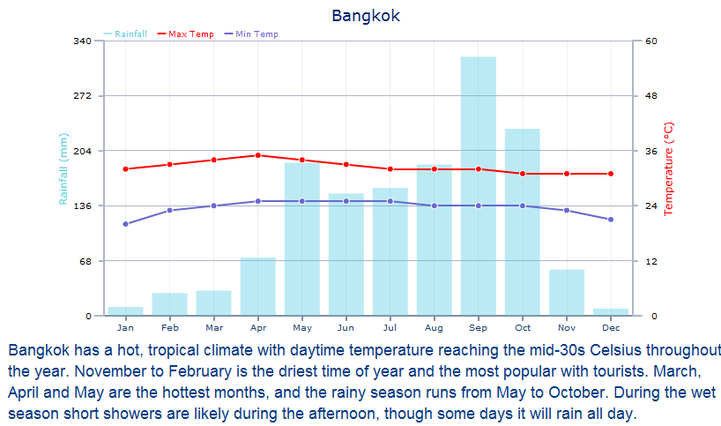

http://www.bbc.co.uk/weather/world/city_guides/results.shtml?tt=TT002890

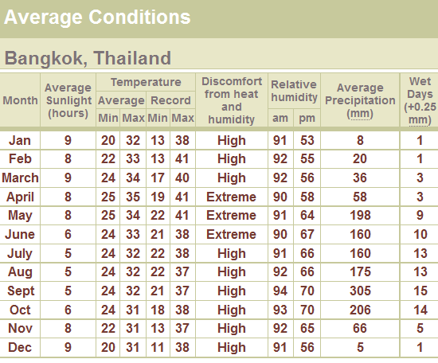

Rail

Trains to/from BKK and Hualumphong

This may have been posted before, but I missed seeing it. Bangkok Airport has the best bargain I've ever come across. Cross the pedestrian bridge that exits the airport to the small train station. From there it costs 5 baht to get all the way to the main Bangkok train station. Buy your ticket at office on the platform. The usually takes less than an hour (you'd be hard pressed to beat that time except by helicopter), though afternoon rush hour can take a bit longer as the road crossings are sometimes delayed for vehicle traffic.
The current schedule is as follows: Airport to Main Train Station 02:08 (great for those midnight Bangkok arrivals) 04:48, 04:58, 06:08,
06:39, 06:56, 07:25, 07:37, 08:17, 09:13, 10:06, 10:35,-there is break here as these trains are basically commuter trains- 14:43, 16:32, 17:58.
The return to Airport from the Main Train Station 04:20, 05:20, 06:00, 07:00,-commuter break again- 14:00, 16:10, 16:15, 16:45, 17:15, 17:25, 18:10, 19:05, 20:10, 23:40. Buy tickets at the main ticket windows.

State Railway of Thailand
http://www.railway.co.th/English/Time_HTML.asp

Bus

Accommodation

Bangkok

Chiang Mai
http://www.thegardenchiangmai.com/rooms.php

Health

Tips Tricks and Traps

Cities and Towns

++++++++++++++++++++++++++++

*** Malaysia

++++++++++++++++++++++++++++

++++++++++++++++++++++++++++

*** Cambodia

++++++++++++++++++++++++++++

Telephone numbers
Bonthong Leap 012 416 127
Sombarn, crocodile ate his phone
Mr. Pastor (Kim Leang) 092 552 271

Map
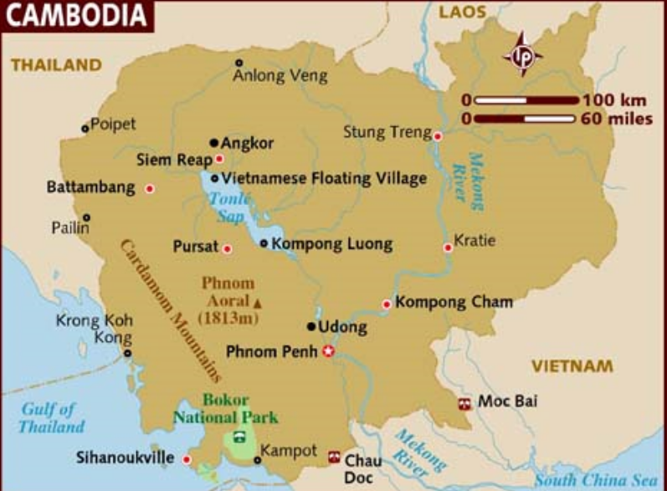

Visa
The Ministry of Foreign Affairs and International Cooperation has launched e-Visa which enables you to apply for a Cambodia travel visa online. Instead of applying through Cambodian Embassy, all you need is to complete the online application form and pay with your credit card. You will get your visa approved within 3 business days.
Single entry, valid for 3 mo, 30 days length of stay $25usd
http://www.tourismcambodia.com/News/e-visa/

http://www.mfaic.gov.kh/evisa/

Online Guides
http://www.canbypublications.com/

Food
From reedrunner59, tt: Groo, yep, a good fish amok, splendid.., in fact the barbecued 'barracuda' down on the beach i had must rate as one of the best bits of fish i have ever had, just simple cooking.

Currency
The Cambodian riel, denoted by KHR, is the official currency of Cambodia. Divided into 100 sen, the Cambodian riel is mainly used for buying local produce.
The Cambodian currency is called Riel. However, most Cambodians use US dollars as well as their own currency. Even the littlest shops quote prices in US dollars.

Weather

Phnom Penh
http://www.bbc.co.uk/weather/world/city_guides/results.shtml?tt=TT002520
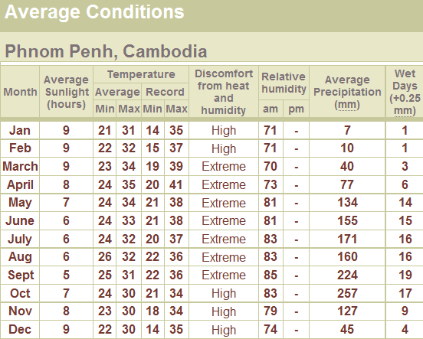

Rail

Bus
Bus schedules and good writeup
http://www.canbypublications.com/cambodia/buses.htm

montyman, TT: get the cheapo bus direct to HCMC from Phnom pen $6-$10 drops you off district 1 De Tham st here are cheap GH's

from henningwessel, tt: [asked about bus from hcmc to Siem Reap] Best: Get a bus (Mai Linh, Mekong Express or SAPACO, all 6 hours, around 12- 14USD) to Phnom Penh, overnight, get bus to Siem Reap (Mai Linh, Mekong Express, Capitol Tours, Rith Mony, Paramount Angkor, 6 hours, 5- 10USD).

From DubinNYC, tt (in response to above): As #1 suggests, I did this just the other day. Took Mekong Express from Saigon to phnom pehn, $12, and took 7 hours altogether. We stayed in PP for a couple of days, and then Mekong express to SR, $11, about 6 hours. No problems, bus leaves exactly on time, we booked a day and half in advance, bus was full both times.

From cbburns, tt (in response to above): Exactly as above. See http://www.canbypublications.com for schedules. Mekong Express costs a couple of dollars more than some others, but they have nice buses with toilet on board. Worth it for sure. FYI, there are NO trains on this route.

Accommodation

Kampot
Blissful guest house. R shared bath $3, ensuite $5

Siem Reap
Siem Reap Hostel has pool, Hostelbooker, $8 dorm

Health
From Soksabai, TT: I think you will find that where ever you go it will actually be the Pasteur Institute that you are referred to for blood tests.
I dont know about general practitioners in Sihanoukville, and there are plenty of dodgy clinics all round Cambodia, but there are a few in Phnom Penh that I know to get a referral (unless you have one already). The Family Medicine Practice in PNH is run by a very competant Philipina doctor and there is also a Russian doctor Ludmilla - both are in the Cambodian yellow pages - that can refer you for blood tests. I have some experience of both Calmette and Naga. As I am sure you would know Calmette is a hospital and quite a Cambodian one at that while Naga is a clinic. Naga has both international and Cambodian doctors and appears to be quite well equipped and modern. My Calmette experience was very Monty Python.

Tips Tricks and Traps
From tt: decent quality fake backpacks in Phnom Penh? At the Russian market ( tol thom puong).- there are two stalls next to each other, good assortiment, decent prices
From Montyman, tt: I usually prebook with Guest House in PP buses its so much easier for their small commission.

From reimund, tt: I work as an English teacher in Siem Reap. If you are looking at volunteer teaching in the poor villages, there is a huge need, and not other qualifications needed than speaking good English. But no salary :(

Cities and Towns

Kampot/kep
See reference in Battambang

Battambang
From ang40, TT: Battamabang is a terrrifc town for a few days of chilling out, and we also love Kampot/Kep area. Very laid back and can really get closer with the Cambodian people. Rabbit Island for a night is also fun and relaxing. But this all depends on what you like? this might be ok for myself and husband who like the laid back style of travelling and enjoying good food and a few cocktails, watching the world go by and chatting with the locals.
canbypublications have a terrific amount of up to date info too.
PM - me if you are interested in these towns.

Siem Reap

Ratanakiri
- Hill tribes
  - In far eastern Cambodia, not far from Vietnam and HCM museum

++++++++++++++++++++++++++++

*** Laos

++++++++++++++++++++++++++++

Map
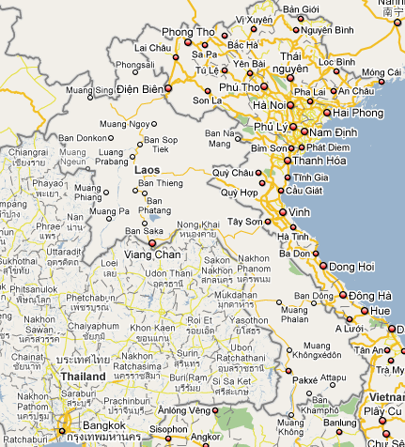

Visa
A Tourist Visa for the Lao PDR is available from a Lao Embassy; a Lao Visa on arrival for 30 days can also be obtained at most border crossings and ports of entry, except overland from Cambodia.
The 30 day visa on arrival in the Lao PDR is available at all ports of entry in Laos including the three international airports of Vientiane, Luang Prabang and Pakse. You should try to have one photo. $35 for the USA
http://www.retire-asia.com/lao-visa-on-arrival-30-days.shtml

Online Guides

Food

Currency

Weather

Vientianne
http://www.bbc.co.uk/weather/world/city_guides/results.shtml?tt=TT002550
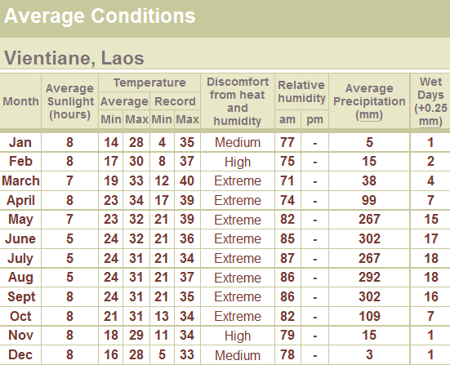

Luang Prabang
http://www.bbc.co.uk/weather/world/city_guides/results.shtml?tt=TT002540
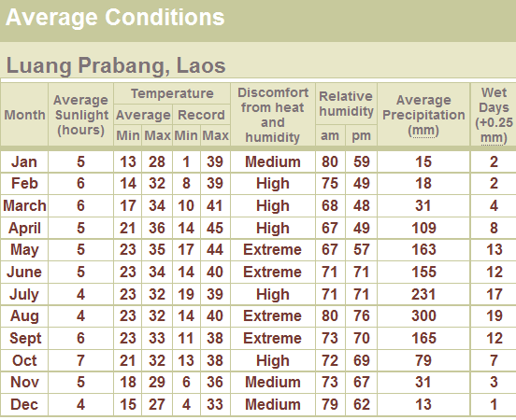

Rail

Bus

Accommodation
From themeffan, TT: From what I recall of my trip to Laos last year, a budget hotel room will cost you ~$7USD a night (with fan, shower), a meal ~$4USD, a beer ~$.5USD, a bike rental ~$3USD/day. I found it to be the least expensive of the four countries I visited (Laos, Thailand, Vietnam, and Cambodia). To give you some perspective, for a 2-month trip through the area I spent a whopping total of $2,000 and that includes visas, a handful of inter-country flights, and excursions. You get a lot of bang for your buck!

++++++++++++++++++++++++++++

*** Vietnam

++++++++++++++++++++++++++++
Tet: Cat, Feb 3 2011

Telephone Numbers
Contact: :guillermintara@gmail.com :kamiyamaso@hotmail.com
Phone: (84.8)-62 913 028
Address 1: 48 Dong Du Street
Q1
HO CHI MINH CITY VIETNAM
(84.8) 62 913 028

Van
Nguyen Thi Van
378 Hung Vuong
Hoi An
Quang Nam
+84 120 271 2245

Possible itinerary
- North Vietnam in Sept/Oct, maybe Nov
  - Feb bad month for N Vietnam
- HCMC = 88Hi for all 3 of those months, so no problem

Checklist
From Irene Adler, in Central America TT:
Some Suggestions:
I can pack everything I need for an extended trip into a carry-on sized bag by choosing clothes that layer. I have a carry-on sized conversion pack (straps tuck away as needed) that has an attached day pack. I pack valuables and some personal items in the day pack and most of the clothes (that I'm not wearing) in the main compartment. Here's what I took to Honduras to accommodate 2-3 weeks inland with high altitude mountain hikes included and 2-3 weeks of beach time:
3-4 wicking-type shirts
1 light weight long sleeved shirt
2 pairs of light weight convertible (zip off to become shorts) long pants
1 sarong (skirt, swim wrap, doubles as towel or sleeping sheet)
1 bandana and one silicon-neck-cooler bandana
1 sunhat with strap
1 light weight sleeveless nightgown
2 swimsuits
1 light weight fleece jacket (liner type that can be worn alone)
1 light weight goretex rain coat
uns and socks (incl. 1 neoprene pair I wear under Keens for hiking and under fins for diving/snorkel’g)
flip flops for beach and showers
Keen water shoes for everything else, including lots of light hiking (they have great support and a rubber toe protector); if you're planning hardcore hiking, take boots
Cash, ATM and VISA cards, passport, etc.
Flight and lodging reservations, emails, receipts, etc.
Small medical kit and sewing kit
Cheap watch with alarm
Toiletries and prescription meds
Sunglasses, spare glasses, disposable contacts for diving/rainforests
Sunblock and bug stuff (Cactus Juice and Sawyer's Time Release Deet Formula, baby oil for sand flies)
Water purification pump (I'm a budget traveller)
Collapsible drinking cup
LCD headlamp
Compass
Earplugs
Camera, etc. (and underwater bag or 1-2 underwater disposables)
Smallish waterproof binoculars
Guidebook and copied map pages
Laminated plant and animal i.d. cards
Journal/writing materials
Reading material and Spanish/English dictionary
Small gifts for kids and hosts
Small dice and yahtzee papers
A small, flexible disc (like a frisbee)
Various ziplocks, cable ties, small bungie cords
3-4’ of duct tape wrapped around a waterproof marker
String and a few clothespins or 3-4 feet of braided surgical tubing - great clothesline
Half a roll of t.p. removed from core and flattened

Another suggestion:
Well, Hopefulist's packing list is great but it is still a little long in my opinion. My boyfriend and I just got back from a month long trip in Guatemala and we each took carry-on sized backpacks that each weighed 4.5 kg (10 lbs.). Here is what was in mine:
2 pairs of pants- jeans and a pair of capris (I was usually wearing one pair)
4 shirts- 3 short sleeve, 1 long sleeve
5 pairs of light socks
tennis shoes (I was usually wearing these)
3 bras
5 pairs of underpants
1 swimsuit
sunglasses
pen
pocket-sized notebook
guidebook
novel/book
all necessary legal documents, money, etc. (that all fit in my money belt)
2 pairs of cheap earrings and 2 cheap bracelettes
tiny pocket-sized first aid kit
1 toothbrush
toothpaste
soap
1 small bottle of shampoo
deodorant
1 small bottle of sunscreen
1 small bottle of bug repellent
1 light weight "hoodie" jacket
1 raincoat that I used once
1 small towel
1 flashlight
1 camera
1 small alarm clock
1 watch
chloroquin (for malaria prevention) and personal medication
I ended up buying a light weight skirt (for the hot humid jungle), a pack of playing cards, flip-flops (for the shared showers), a razor (not allowed on airplanes), and a nail clipper (also not allowed on planes) while I was there. On our very last day I picked up all our gifts and souvenirs at a craft market in Guatemala city, so I didn't have to haul them around. All the gifts I got also easily fit into my backpack.
I'm usually fairly high maintenance when it comes to clothes and bathroom supplies, but I am sooo glad that I packed light for this trip. I didn't miss a thing (or bought it, if I did) and chuckled to myself every time I saw other miserable tourists hauling around giant heavy backpacks.
Beautiful, light travels to all!
Anni

Thermarest pillow

Map
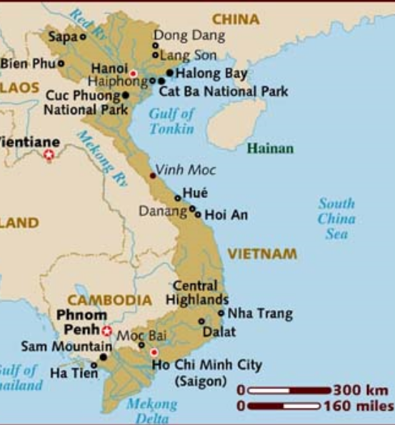
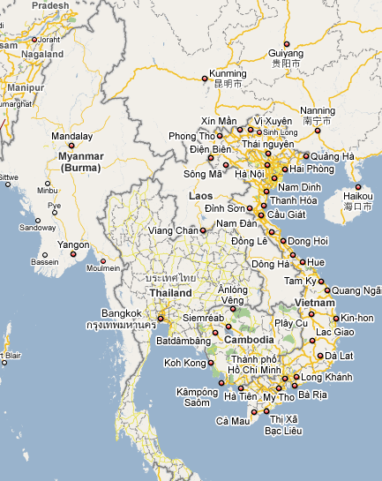

Vietnam/HongKong
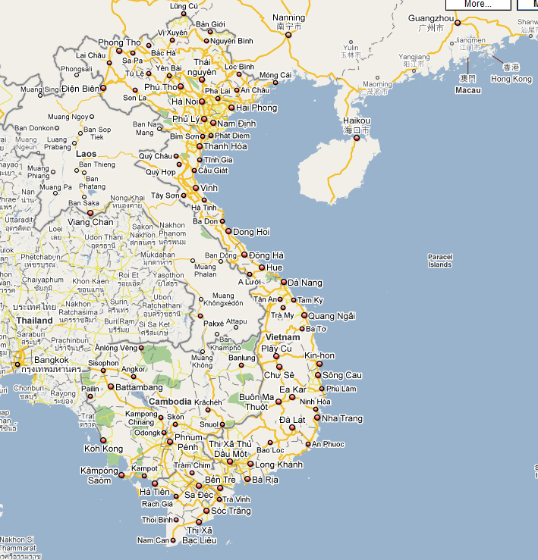
Overland Hong Kong to Hanoi, perhaps $150
. Express train from Hong Kong train station to Guangzhou - 230 HKD (approx $30)
. Taxi from Guangzhou East train station to the main Guangzhou train station. - 16 RMB (approx $2.50)
. Overnight soft sleeper to Nanning - 548 RMB. (approx $80)
. Train from Nanning to PingXiang - 30 RMB. (approx $4)
. Tuk tuk to customs and immigration - 24 RMB. (approx $3.50)
. Taxi to Lang Son - $3.
. Minibus to Hanoi - $3 (Depending on the number of people in the minivan, and the price agreed upon). It takes about 3.5 hours to get Hanoi from Lang Son.
(from Vietnam FAQ, TT)

Cambodia

Laos

Phone
Vietnam uses GSM 900
India GSM 900—5 carriers
GSM 900/1800—3 carriers
Thailand
GSM 1800, 3 carriers
900, 1 carrier
1900, 1 carrier

http://allworldcellphones.com/gsm-frequencies-list.htm
Costa Rica: GSM 1800
Mexico: GSM 1900
Cuba: GSM 900
Guatemala: GSM 850, 1 carrier
GSM 1900, 2 carriers
Vietnam uses GSM 900
India GSM 900—5 carriers
GSM 900/1800—3 carriers
Thailand
GSM 1800, 3 carriers
900, 1 carrier
1900, 1 carrier
US
GSM 850, 14 carriers
1900, 18 carriers
1900/850, 4 carriers

Samsung T429: GSM 850/1800/1900 (Tri-Band)

Nokia 1112: GSM 850/1900
Ebay buy it now: $19, $21

Health
From Violets, TT: I understand that malaria mosquitoes only bite very early in the morning, so if you have closed windows or mosquito nets you have no problems even in a malaria area. This is why Bill Gates charity provides mosquito nets to prevent malaria. Dengue fever is more of a problem but there is nothing you can take to prevent it so should take all the precautions to prevent mosquitoes biting you- long sleeves, light coloured clothing, good mosquito repellent, no perfume or fruit flavoured shampoo or cosmetics.

Weather

Average Conditions

Hanoi
http://www.bbc.co.uk/weather/world/city_guides/results.shtml?tt=TT002920

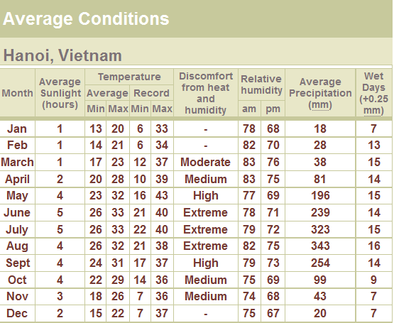

Ho Chi Minh City
http://www.bbc.co.uk/weather/world/city_guides/results.shtml?tt=TT002930

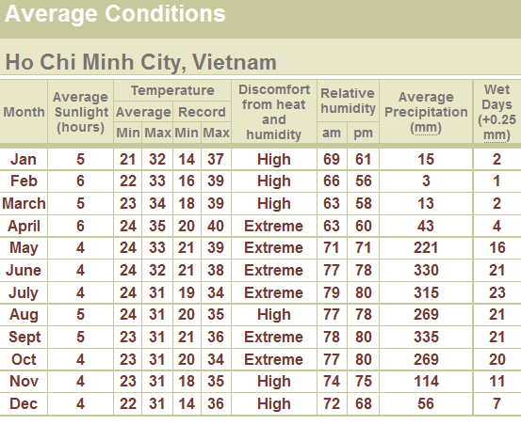

Danang
http://www.bbc.co.uk/weather/world/city_guides/results.shtml?tt=TT002940

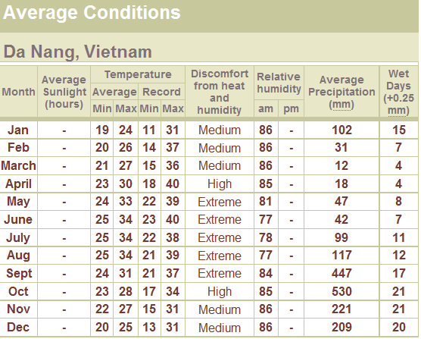

From Junglebeach, TT: summer typhoon are usually in the north, sept to december typhoons are in the south or the north;amazingly, no typhoon has ever hit Khanh Hoa province directly, we just get the tails and outer extremes, which are still quite bad, but nothing like what the north gets; the north is usually the most battered area of vietnam in both rain and typhoon season
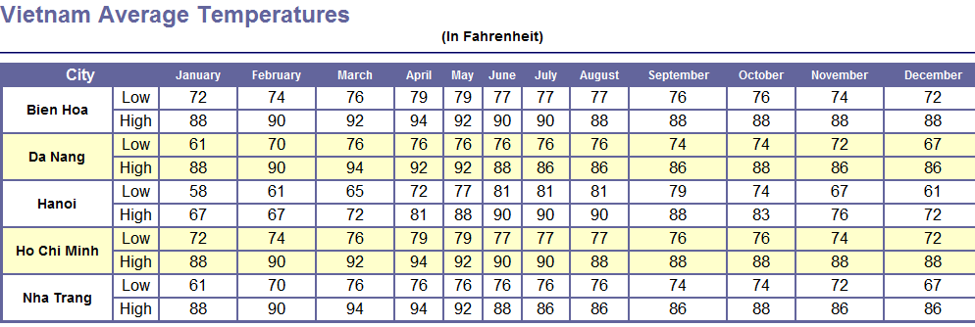

Average high temperatures

Hanoi

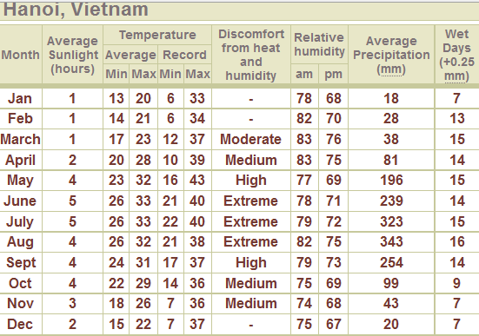

Ho Chi Minh

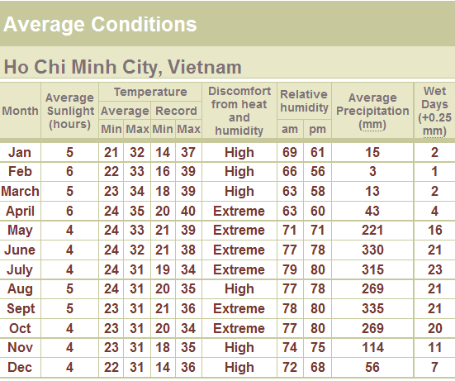

Visa
TT, Vietnam FAQ: Citizens from other countries are still required to get a Vietnam visa in advance. There's no "Visa-on-arrival" at the border crossings or at the international airports in Hanoi, Da Nang and HCMC. As I said, you must have a visa for Vietnam in advance. The visa fees at the Vietnamese Embassies and Consulates are different, so don't be surprised if someone has paid more or less, when they applied for a visa in Bangkok, Vientiane, Phnom Penh or at home.

Website: http://www.myvietnamvisa.com/visa-requirements/united-states.html

http://www.vietnamembassy-usa.org/consular_services/

from lee57, TT: My wife and I used Aurora Travel that runs the http://www.vietnamstay.com website after the recommendation of one of our friends and honestly we could not fault the company and the service for any reason. At our very first stage of planning, we were lured when looking at some local companies' websites which offered the same service at considerably varying prices, but on second thought, we decided to use Aurora for its reputability and reliability and would happily recommend it to everyone.

For extensions:
http://www.myvietnamvisa.com/vietnam-visa-extension.html

from cmburns, tt: Easy, and usually cheaper that getting a visa from an embassy/consulate. I've used VietnamStay.com and http://www.hotels-in-vietnam.com both have good service, but H-in-V is cheaper with only a $14USD fee for the approval letter.
Remember the pre-arranged visa approval letter only works for arrivals by AIR.

From nervouslady, tt: I obtained a LOA from MyVietnamVisa and there were no problems at all with the legitimacy, cost, convenience or speed of service (letter was emailed to me within three days as promised). However- a couple of things you should take into account.
1. When you get the letter it will have your name and the name of several other tourists, together with their dates of birth, nationality and passport numbers. So if you are concerned about privacy this may not be the option for you.
2. When you arrive in HCMC you will have to go to another counter (not very well sign-posted) to get your visa before proceeding to the immigration queues. I waited half an hour at this counter even though there were only 10-15 other people ahead of me and 4 people working in the office. In the meantime all the other passengers on my flight cleared immigration, collected their bags and my baggage was going around on the carousel unattended when I finally got there.
3. I saw a few people in the queue who had not filled out the exit and entry form and attached the passport photos and they were being given a very hard time (mind you, there really is no excuse for not knowing this part-your LOA provider will explain the process quite clearly)

Border Crossings
From henningweasel, TT: Crossing from Savannakhet to Hue is easy.
If you have a bit of time any border crossing is easy, including the one in the north from Muang Khua to Tay Trang and Dien Bien Phu.
The buses from DBP to Sapa go through some stunning scenery, definitely worth it.

Online Guides

Food

Currency
As of 5/31/09
20,812 VND per usd

1 U.S. dollar = 6.82780281 Chinese yuan (RMB) (CNY)
1 usd = 7.7 HKD

From Maureenm, TT: Charge to use ATMs in VN can be quite large actually. Local banks charge 1% service fee for using an ATM which is fine. Home banks also charge, although they provide no service. They charge you for NOT using their ATM and also for converting the dong withdrawal into the home currency. Some report charges of around $10.
So, before you leave, check with your bank to see what its charges will be for each ATM withdrawal made in VN. Outside the major cities the maximum withdrawal per transaction is 2 million VND and you can make up to 5 of these in a day. The costs soon mount up so be prepared.

Misc Transport
Man in seat 61

For instance you can catch a series of boats through the Mekong Delta from Ho Chi Minh City (Saigon) to Phom Penh, Cambodia. From there it's a $10 bus ride to Siem Reap (http://community.webshots.com/photo/fullsize/2436950850070201088cNgUlz). My 2-day river boat tour (http://www.flickr.com/photos/24957955@N07/2361848011/in/set-72157604252188906/) of the delta (http://www.flickr.com/photos/24957955@N07/2361916493/in/set-72157604252188906/) was the highlight of my 2008 Vietnam visit.

Buses

From Montyman, TT: multi stop "Open bus" to Hanoi via Dalat Natrang hoi An hue etc

Open Bus
TT: http://www.sinhcafevn.com/Open_Tour.asp
From Montyman: I used these and they did my cuuchi tunnels trip also I think they are all a much of a muchness, same same even around $23 HCMto Hanoi with stops in between ie Dalat a must/ Nathrang for me afternoon was enough, HoiAnn 3 days /Hue and Hanoi
TNK open tour
From VeteranBackpacker: There are many open tour bus companies, of which Sinh Cafe is one, and all operate according to the same hop on, hop off principle. You can either buy a ticket all the way through to Hanoi and stop off for however long you wish at the major cities on the way, or you can buy separate tickets for each leg. The latter works out more expensive but it offers greater flexibility, e.g. if you decide you can't take any more of buses and prefer to take a train.
The quality of the buses varies enormously between companies and you should check them out before buying a ticket. Some have normal seats that recline only a little and are hellish for a long journey, while the seats on sleeper buses allow you to lie almost horizontally. I have travelled with Trekking Travel on the overnight Ninh Binh to Hue leg, and with Hahn Cafe on the much shorter Hue to Hoi An leg. Both companies were fine, although the seats on the platform at the back should be avoided at all costs as you're tossed about like a sack of potatoes. For all seats, if you're taller than about 5'8" and/or wider than 18" you'll be somewhat cramped.
From westwood: We did the buy as you go but before the days of the sleeper buses. We used whichever company our accommodation booked for us and had no problems. But in Hanoi, we got dumped God only knows where ( we never figured out the location) to be met by a pile of touts on motos.

Cities and places

Hanoi

Highly recommended motorcycle rental.
http://hanoimotorcyclerental.com/
Talking about the motorbike we rented from here: http://hanoimotorcyclerental.com and they were great. We had to put a fairly hefty deposit down but the bike was a dream and no quibbles on our return.

Danang
http://danangkids.org/

danangkidsvn@gmail.comdanangkidsvn@gmail.com

Ninh Binh
From solohobo, tt: You may also want to consider the Ninh Binh areas 2 hours south of Hanoi. There is a great national park nearby, as well a lake region and also lots of ethnic areas for Homestays

Halong Bay
From Muzzman, tt: Handspan is a great company - I have used them on 4 occasions. Handspan has a great reputation, thus I would book in advance. I believe they will ask for a cc #, if so, I would give it to them (they are a very reputable company).

Halong Bay could be done in 1 day, begin 8am end 7pm; travel agencies in Old Quarter of Hanoi

Near Nha Trang
Syl and the gang @Jungle Beach VietNam
syl@dng.vnn.vn
tel: 058-3622384 091-3429144
http://www.junglebeachvietnam.com

Saigon/HCMC
http://www.concierge.com/travelguide/hochiminhcity/nightlife/42382
Sax n' Art Jazz Club
28 Le Loi Street
District 1
Ho Chi Minh City
Vietnam
Tel: 84 8 822 8472

From daawgon TT: I went to the Delta for 2 days, and came back to Saigon, but stayed at the Bich Duyen just down the street. What an improvement, and cheaper @ $25. The Bich is the place to stay in the area - I loved that little place! No balcony there, and no view, but the place is so well run (you could eat off the floor) by the wonderful manager, Chanh. I will be staying at the Bich when I return to Saigon - no question!

Dalat
From AlegreViajero, TT: What is first noticeable on arrival is the cleanness of the city, the pastel colours of the houses and the flowers. Because it is a very hilly city, the view is superb from every where.
They say Dalat is the City of Love… We could also say of Dalat: The City of Flowers, the City of Romance, the City of… 100+ cheap hotels (my very large room: Internet, toilet and shower, fridge, cable TV, balcony with a breathtaking view over the city: $7 US a night!). Dalat is and also the City of 500 Café! Their espresso coffee is simply exquisite. (Coffee harvested in the region)

From TravelingKid, TT: : Valley of Love: Not the big one but a newly built small one next to it. Tell the motorbike the one which has a mini version of the Great Wall of China, riding a horse carriage from town to there is fun too.
: Lake of Sorrow on the northeast side of the city.
: 2 flower gardens.
: 3 summer palaces of VN last Emperor Bao Dai.
: Truc Lam pagoda
: 3 big waterfalls around the city Prenn, DaNhang and CamLy.

Easy Riders
From Kieranmcg2000, TT: Highly recommends Easy Riders.
http://www.lonelyplanet.com/thorntree/thread.jspa?threadID=1868796&tstart=0

Sa Pa
From jano422, TT: See my post 11-Aug - Trip report - practical information where I recommended Hoang Long Hotel.
I agree with the travellers feedback on that website http://www.sapa-hotels.com/Hoang_Long/accm_your_host
If you book through sapa-hotels you can pay with paypal.
Things to Do

From SoloHobo, TT: The best market I encountered in VN was in Sapa, the ethnic tribes have certain days they trade and come down from the villages in their traditional dress, women, children and men. Not sure what was at the market, but the scenery was a postcard.

Can Cau and Bac Ha
We went to Can Cau on Saturday and Bac Ha on Sunday. Can Cau had very few tourists, a stunning setting, and loads of Flower H'mong. Since I didn't visit all the markets, I can't say if its the best, but it was definitely a highlight of our trip.

Hoi An
From Tungurahua, tt : I did Hoi An to Hue by motorbike up into the mountains along the Ho Chi Minh Trail, which goes into Laos at one point (no passport control so no passport/visa needed). Drunk rice wine with some mad locals. Stayed in a no horse town. All courtesy of Minh and the My Chau hostel (not sure if he still does it. I guess he does.). A cafe owner told us she'd been told the water up there still has dangerous levels of agent orange in it!
There's some nice cycling around Hoi An, including paddy fields, but also things like peanuts!

Fish markets - my favourite was the Hoi An fish market, but again, go early in the morning (before 7). There should also be an interesting one in Phu Quoc island's main port.

HCMC
From NormC, tt: If you like Spanish music and a bit of a dance, then go to the Carmen Bar at 8 Ly Tu Trong Street Saigon. Live music starts at 9pm and goes to midnight.Also have western music and singing. Coronas are 130,000 VND.

Contact us TaraKys.com

Contact: :101cat@vnn.vn :kamiyamaso@hotmail.com Phone: (84.8)-38 238 149 Address 1: 101 DongKhoi Street Q1 HO CHI MINH CITY VIETNAM (84.8) 38 238 149

Accommodation
From beforeyougo, TT: It's easy to book hotel in the big city like Hanoi, Ho Chi Minh, Da Nang when you get there but you'd better book in advance when you plan to go to North west or north east vietnam.

Great hotel booking site, very well-organized:
http://www.hotels-in-vietnam.com/index.html

Ninh Binh
From shibamido, tt: On the contrary, our booking at the Xuan Hoa Hotel was a great choice. Staff was friendly and able to communicate in very good English. They booked a car and driver for 30usd for the next day for us to visit some relatively unexplored sites, and it was great. We were even offered a free shower after checkout. Great service, recommended. [very mixed reviews on TripAdvisor, but apparently recommended by LP]

Health

Tips, Tricks, and Traps
- Don't use open bus, don't use bus at night.

From 2Canadians, TT: Is it normal for a tour company in Vietnam to want you to fax photocopies of the front and back og your credit card? I am a little hesitant to do so. The operator in question is Handspan, who seem to have a good reputation for being legit. Any advice?
From SoloHobo, TT: This is the only way to book in many developing countries, like Costa Rica too. They need the front and the back due to Bank requirements to prove its legit and not just a CC # you provide from a reciept you found. Its normal.
Handspan is A+ sterling reputation on the forum and also I used them as well, no complaints about them on this TT.

Cat Ba Island
One weekend in April, residents push their houseboats together and celebrate Ho Chi Minh’s visit to the island in 1959

Mekong Delta
From jezebelle, TT: We want to see a mixture of quiet little canals and rural life, as well as floating markets etc.

From nijkerk, TT: Hoi An isnt in the Mekong Delta. Travel is easy to organise yourself in the Delta. Buses/Minibuses go everywhere. A day and an overnight stay in Chau doc is imo worthwhile for the markets alone .Youll arrive there if you are coming by boat from PP

Mekong River
From annebe9554 TT: We (family of 4, including two children 10 & 13 - excellent travellers) are going to Vietnam in July. Unfortunately only for 15 days. Would love to include a Mekong Delta trip with an overnight on a boat. Can anyone recommend a good company that we can use? Have heard good things about Mekong Eyes, but it is rather out of reach of our budget - would probably not be able to spend more than $300 for all four of us. Am I being unrealistic?

From hewy76, TT: No you are not being unrealistic. We paid 23US each for a overnight trip staying on a boat. Food was extra but prices were resonable. It is a budget tour at that price, but was good fun. Its organised chaos. Herded on to a large bus, with mutliple tours, groups split up at the wharf, overnight on the boat in a large shared dorm room, then the next day other tours join you on your boat as there tour included a day cruise on a boat etc. Hope you get my drift! But for the price you can't complain. I think we booked through delta adventures.The overnight boat is a good option. It had deck chairs on top and was a great place to meet new people and watch the sun go down. Beers were very cold and cheap aswell!

Touring
N-S, or S-N? On TT, four posts said it makes little difference.
From lee57, TT: It makes no difference if you make your way from the North to the South or vice versa, but just noticed that you're traveling in September, so, in my opinion, you'd better start from the North as the weather will be of its finest at that time (autumn).
We had no trouble finding a good English speaking guide when we were traveling in both regions a couple of moths ago. However, you'd struggle to hire a local driver who speaks good English.

Jazz in Hanoi
Minh’s Jazz Club on Luong Van Can Street is an exception and a must-see for all jazz lovers.

++++++++++++++++++++++++++++

*** Indonesia

++++++++++++++++++++++++++++

Telephone Numbers

Possible itinerary
Tana Toraja, indigenous tribes. See Carol’s PDFs. On Sulawesi, 300km north of Makassar

Checklist

Map

Phone

Health

Weather

Average Conditions

Visa

Border Crossings

Online Guides

Food

Currency

Misc Transport

Buses

Cities and places

Health

Tips, Tricks, and Traps

++++++++++++++++++++++++++++

*** Health Stuff

++++++++++++++++++++++++++++

Immunizations, from other travelers
From sywanyk, TT: t he shots I got were Hep A & B, tetanus/diphtheria, MMR, typhoid, polio, and I will pick up anti-malaria pills when I arrive in Mumbai.
From laketraveler, TT: I didn't get any special immunizations. I just went with the ones I already had (tetnus, Hep A & B, polio, etc.).

Immunization History
Name Date(s) Administered
• HepA (Hepatitis A) 08/07/2007
• HepB (Hepatitis B) 08/07/2007
• IPV (Polio-adult 19 years and older) 08/07/2007
• Influenza (.50 not PF) 10/07/2008
• PCV (Pneumococcal conjugate) 11/17/2005
• Td PF (Tetanus, Diphtheria) 01/07/2010

GHC Coverage Notes
- Prescriptions? No
- Doctor visits? No
- Emergency services (ER) covered with $50 co-pay; applies per visit
- Hospitalization? Full $200 per day for 1st 5 days; ER co-pay waived if admitted; $1,000 max
  - How long? (up to $1000 max)
  - Limit per day? $200
  - Tests? Covered under emergency co-pay
  - Exclusions? None she knew of
  - ambulance covered with $150 co-pay
  - Evacuation? Not covered
- Time limit in submitting receipts for reimbursement? 1 year

Immunizations I want to get
- Hep A & B combo

For injections at Olympia Medical Center: Please call 360-923-7740 Monday-Friday 9am to 6pm to make an appointment for travel injections.
Scheduled for 2pm Thurs 9/23

Thurston County Health Dept
867 2500
786 5581 for immunization
www.co.thurston.wa.us/health
www.cdc.gov travel section

GHC Travel Meds for India and SE Asia

8/20/2010
Estimated Price List for Travel Medications & Immunizations
**At each visit there is a $22.00 Immunization Administration fee for one vaccine and $12.00 for each additional vaccine.**
Immunizations (price per dose):
-$73.00 Hepatitis A (covered vaccine ages 1-18)
-$95.00 Hepatitis A & B combination (Twinrix)
-$111.00 Japanese Encephalitis (ages 1-17)
-$222.00 Japanese Encephalitis (ages 18 & above)
-$120.00 Meningococcal polysaccharide
-$110.00 Meningococcal conjugate (approved for ages 11-55; covered ages 11-18)
-$47.00 Polio - Adult
-$221.00 Rabies - Intramuscular
-$192.00 Shingles
-$55.00 Typhoid - Injectable
-$93.00 Yellow Fever
Medications:
-$48.00 Typhoid - Oral
-$5.00 Bismuth Subsalicylate Tabs (Pepto Bismol) [30 tabs]
-$2.20 Loperamide (Immodium AD) [12 tabs]
-$12.00 Ciprofloxacin 500mg [6 tabs]
-$17.80 Azithromycin 250mg [6 tabs]
-$13.65 Hydroxychloroquine 200 mg (weekly dose = 2 tabs) [16 tabs]
-$52.00 Mefloquine 250mg (weekly dose = 1 tab) [8 tabs]
-$18.00 Doxycycline 100mg (daily dose) [50 tabs]
-$190.00 Atovaquone/Proguanil (Malarone) 250/100mg (daily dose) [29 tabs]
-$73.00 Atovaquone/Proguanil (Pediatric Malarone) 62.5/25mg (daily dose) [29 tabs]
-$7.30 Acetazolamide 250 mg [6 tabs]
-$24.00 Azithromycin 200mg/5ml suspension [1unit]
-$54.05 Rifaximin 200mg [9 tabs]
**Prices subject to change depending on current cost of drugs.**
4/1/2010

GHC Travel Advisor, India and SE Asia
Thank you for contacting the Group Health Travel Advisory Service. Our purpose is to inform you of the immunizations and medications recommended for international travel.
Based on your specific itinerary and medical history, we have prepared your personalized travel recommendations. Please take time now to review the information regarding your medical history, itinerary and recommended medications and immunizations. In case of error or omission, please notify the Travel Nurse or your physician.
Primary care center: OLYMPIA MEDICAL CENTER
Personal physician: Karen Semones, MD
Age: 71 year old
______________________________________________________________________
Name of caller: Lee R Gilchrist
Departure date: 10/25/2010
Length of travel: Up to 6 months
Itinerary: India, Vietnam, Laos, Cambodia, Thailand, and possibly Malaysia and Singapore
Areas to visit: cities, rural areas, desert
Purpose: vacation
Type of travel: independent
Accommodation: dorm / hostel, hotel
Activities: general tourist
Previous travel outside the U.S.: yes
Previous residence outside the U.S.: yes-Chile
Relevant medical conditions: acid reflux, cardiac
Medications: Reviewed
No Known Allergies.
Immunization History
Name Date(s) Administered
• HepA (Hepatitis A) 08/07/2007
• HepB (Hepatitis B) 08/07/2007
• IPV (Polio-adult 19 years and older) 08/07/2007
• Influenza (.50 not PF) 10/07/2008
• PCV (Pneumococcal conjugate) 11/17/2005
• Td PF (Tetanus, Diphtheria) 01/07/2010
Recommendations:
Immunizations:
- Hepatitis A (Hep A): This vaccine is needed at least four weeks before the start of the trip. This completes the series.
- Hepatitis B (Hep B): This vaccine is needed immediately, third and final dose two or more months later.
- Japanese Encephalitis (JE-Ixiaro): This vaccine was discussed and declined.
- Rabies: This vaccine was discussed and declined.
- Shingles: This vaccine was discussed; will consider.
- Typhoid (Live), Oral: You will be given 4 capsules. Take 1 capsule every other day with cool water one hour before a meal until finished. Keep capsules refrigerated. Do not start within 3 days of taking any antibiotic. Complete at least 3 days before starting any antibiotic including doxycycline. This vaccine is needed at least four weeks before the start of the trip.
Malaria Prevention:
- Doxycycline 100 mg. # 60: Take 1 tablet once daily starting 1-2 days before malaria exposure, during exposure, and for 4 weeks after leaving malarious area.
Areas of India with Malaria: All areas throughout country except no malaria in areas >2,000 m (>6,561 ft) in Himachal Pradesh, Jammu, Kashmir, and Sikkim. Present in cities of Delhi and Bombay (Mumbai).
Areas of Laos with Malaria: All, except none in the city of Vientiane.
Areas of Cambodia with Malaria: Present throughout the country, including the temple complex at Angkor Wat, except none in Phnom Penh and around Lake Tonle Sap.
Areas of Thailand with Malaria: Rural, forested areas that border Cambodia, Laos, and Myanmar (Burma). Rare local cases in Phang Nga and Phuket. None in cities and in major tourist resorts. None in cities of Bangkok, Chiang Mai, Chiang Rai, Pattaya, Koh Samui, and Koh Phangan.
Areas of Malaysia with Malaria: Present in rural areas of Malaysian Borneo, and to a lesser extent in rural areas of peninsular Malaysia.
Diarrhea Treatment:
- Loperamide 2 mg (Imodium AD) #12: For diarrhea beyond Pepto Bismol relief. Take 2 tablets when starting antibiotics for traveler's diarrhea, then 1 after each loose stool. Not to exceed 8 doses in 24 hours. This is an antimotility drug which slows the bowel activity. Do NOT use this if you have a high fever or bloody diarrhea. This is available without a prescription.
- Azithromycin 250 mg #6: Take 2 tablets once a day for 3 days as needed for traveler's diarrhea. If symptoms cease, you may discontinue use of this antibiotic.
Other Recommendations:
- Protect yourself from mosquito and other bug bites. Insects may transmit disease such as chikungunya fever, dengue fever, Japanese encephalitis and malaria. If insects are present, wear protective clothing on arms and legs and use insect repellant containing DEET on exposed skin. Recommended products available at REI (www.rei.com): Sawyer Controlled Release, REI Jungle Juice Plus, 3M Ultra Thon. Additional protection for clothing: Sawyer Permethrin Pump Spray or Military Treatment or purchase pre-treated Buzz-Off or Insect Shield clothes.
-Avoid contact with animals. Any animal bite or scratch should receive prompt local treatment by thorough cleansing of the wound with copious amounts of soap and water and a povidone-iodine solution if available; this local treatment will susbstantially reduce the risk of rabies. Seek immediate medical care.
- As a precaution against avian flu, avoid all direct contact with poultry, including touching well appearing, sick and dead chickens and ducks. Avoid places, such as poultry farms and bird markets where live poultry is kept and avoid handling surfaces contaminated with poultry feces or secretions. Eat only well cooked meat and eggs from domestic and wild birds.
Your travel advisory recommendations have been sent to your primary care clinic.
Instructions to arrange for care:
Please contact your physician's office with fax number for Costco pharmacy and ask her to fax travel medication orders to Costco.
For injections at Olympia Medical Center: Please call 360-923-7740 Monday-Friday 9am to 6pm to make an appointment for travel injections.
Most insurance plans cover updating of routine immunizations (such as tetanus / diphtheria, and measles / mumps / rubella). Vaccines and medications specifically for travel are not covered by Group Health. In addition to the cost of the vaccination(s), an administration fee is charged at each visit. Travel vaccines and medications are paid for at the time of the service.
We have discussed and/or sent you the following information:
Avian flu
Centers for Disease Control and Prevention Country Information
Dengue
Diarrhea prevention and treatment
Food and water precautions
Insect precautions
Insect repellent
Oral rehydration
Prescription Drugs for preventing Malaria
Rabies
Sun protection
Travel/evacuation insurance
Prices
We have sent the following vaccine information statements:
Hepatitis A, Hepatitis B, Inactivated Influenza, Japanese Encephalitis (Ixiaro), Rabies, Shingles and Typhoid
We have listed some web sites below that may be of interest to you if you would like additional information.
For clarification of medical coverage while out of the country, please call Group Health Customer Service at (206) 901-4636 (toll-free 1-888-901-4636).
Best wishes for a pleasant journey.
Sincerely,
Your Group Health Travel Advisory Service
Stacy Kiyasu, RN
Travel Advisory Service Nurse
206.326.3838
800.562.6300 ext 3838
* * * * * * * * *
Travel Web Sites:
India http://wwwnc.cdc.gov/travel/destinations/india.aspx
Vietnam http://wwwnc.cdc.gov/travel/destinations/vietnam.aspx
Laos http://wwwnc.cdc.gov/travel/destinations/laos.aspx
Cambodia http://wwwnc.cdc.gov/travel/destinations/cambodia.aspx
Thailand http://wwwnc.cdc.gov/travel/destinations/thailand.aspx
Malaysia http://wwwnc.cdc.gov/travel/destinations/malaysia.aspx
Singapore http://wwwnc.cdc.gov/travel/destinations/singapore.aspx
Air Travel Infections and Safety - http://www.tsa.gov/public/display?theme=175
CDC Travelers Health - http://wwwn.cdc.gov/travel/default.aspx
Dengue Fever - http://wwwn.cdc.gov/travel/yellowbook/2010/chapter-5/dengue-fever-dengue-hemorrhagic-fever.aspx
Flu - http://www.cdc.gov/vaccines/pubs/vis/downloads/vis-flu.pdf
Hepatitis A - http://www.cdc.gov/vaccines/pubs/vis/downloads/vis-hep-a.pdf
Hepatitis B - http://www.cdc.gov/vaccines/pubs/vis/downloads/vis-hep-b.pdf
Immunization Information - http://www.cdc.gov/vaccines/
Malaria Prevention - http://www.cdc.gov/malaria/pdf/travelers.pdf
Medical evacuation travel insurance - http://travel.state.gov/travel/cis_pa_tw/cis/cis_1470.html#companies; International SOS - http://www.internationalsos.com/buymembership/index.cfm?theaffiliateid=1299; Divers Alert Network - http://www.diversalertnetwork.org/membership/index.asp
Mosquito / Insect Precautions - http://wwwnc.cdc.gov/travel/yellowbook/2010/chapter-2/protection-against-mosquitoes-ticks-insects-arthropods.aspx
Transportation Security Information - http://www.tsa.gov/travelers
Travel warnings from the U.S. Department of State - http://travel.state.gov/
Typhoid - http://www.cdc.gov/vaccines/pubs/vis/downloads/vis-typhoid.pdf
World Health Organization - http://www.who.int/ith/en/

++++++++++++++++++++++++++++

*** Skeleton Categories

++++++++++++++++++++++++++++

Telephone Numbers

Possible itinerary

Checklist

Map

Phone

Health

Weather

Average Conditions

Visa

Border Crossings

Online Guides

Food

Currency

Misc Transport

Buses

Cities and places

Health

Tips, Tricks, and Traps

